A new precursor for bacteria-based self-healing concrete derived from organic waste streams

Emanuele Rossi¹, Chris Vermeer², Robbert Kleerebezem², Oguzhan Copuroglu¹, and Henk Jonkers^{1,*}

¹Section Materials & Environment, faculty of CEG, TU Delft
²Section Environmental Biotechnology, faculty of AS, TU Delft
*Corresponding author: h.m.jonkers@tudelft.nl

ABSTRACT:

(one-page maximum)
Crack formation is a common phenomenon affecting concrete performance. Cracks lead to ingress of water and deleterious materials into the concrete matrix, thereby increasing the risk of degradation and reducing the service life of structures. Maintenance and repair of concrete structures are undesirable because very money- and time-consuming. By preventing the water ingress into concrete, durability can be significantly enhanced. Bacteria-based self-healing concrete has the ability to heal cracks due to the bacterial conversion of incorporated organic compounds into calcium carbonate [1-2]. Precipitation of calcium carbonate seals the cracks, waterproofing and increasing the service life of structures and reducing reparation costs. However, one drawback about biogenic concrete is the high production costs of the currently-available healing precursors. Therefore, the aim of this paper is to propose an innovative organic mineral precursor which can be derived from organic waste streams, of which production is in line with the circular economy principle and ideally more affordable than that of other substrates. The proposed healing agent shows promising results regarding its limited effect on the hydration of Ordinary Portland (OPC) and blast furnace slag cement (BFSC). The self-healing capacity of OPC-based mortar with added-in healing precursor particles is also demonstrated through microscopic observations (Figure 1). Since this innovative system shows considerable compatibility with self-healing concrete, recommendations for future research to implement into the system are also discussed.

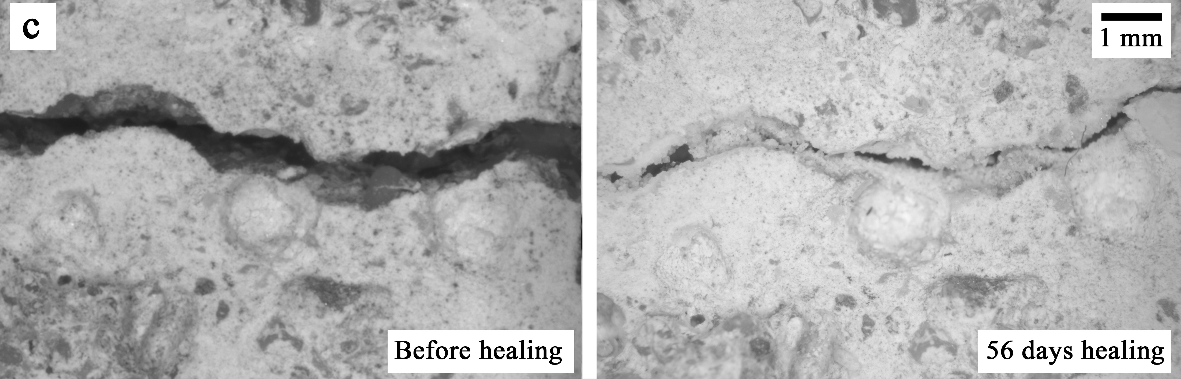

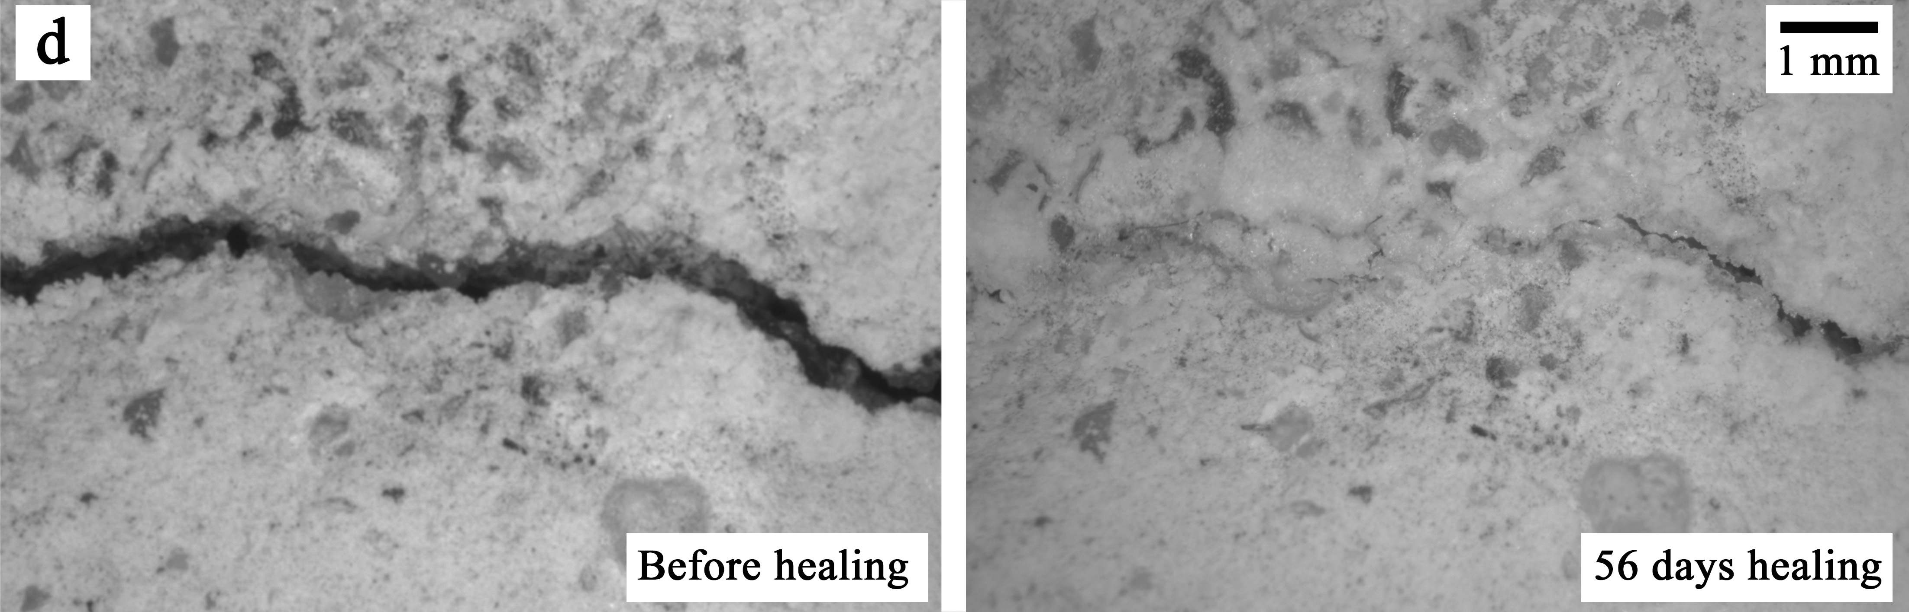
Fig. 1. Surface cracks before (left) and after 56 days of self-healing incubation at RH > 95% and 20°C (right).
Each two images refer to one sample of each series (a for C0, b for C56, c for B0 and d for B56).

References:
- H.M. Jonkers, A. Thijssen, G. Muyzer, O. Copuroglu, E. Schlangen, 2010. Application of bacteria as self-healing agent for the development of sustainable concrete. Ecological Engineering, 36:230-235.
- R.M. Mors, H.M. Jonkers (2017) Feasibility of lactate derivative based agent as additive for concrete for regain of crack water tightness by bacterial metabolism. Industrial Crops & Products 106: 97–104.

